**Task 1**

**Add Item:**

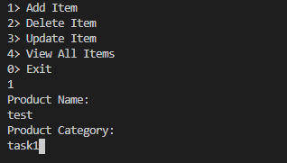

A random ProductID is generated and associated with the product.

**View Items:**

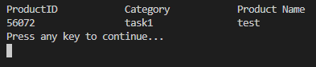

**Update item:**

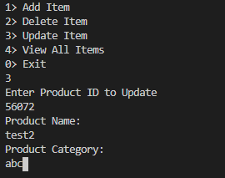

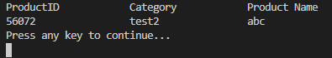

**Delete Item:**

Enter product Id to delete.

**Task 2:**

Press 1 to add

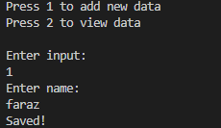

Pressing 2 to view

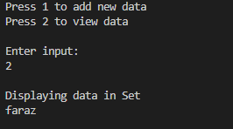

**Task 3:**

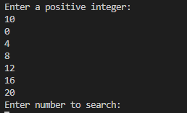

All the even numbers were multiplied by 2 and displayed in the console.

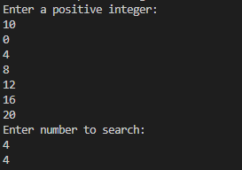

This search operation works when the input number is present in original even number Linked list.